EXPERIMENT NO: 4  **PARALLEL SUBTRACTOR** 20/02/2023

**PARALLEL SUBTRACTOR**

**A0=0,B0=1,BIN=1,A1=1,B1=0**

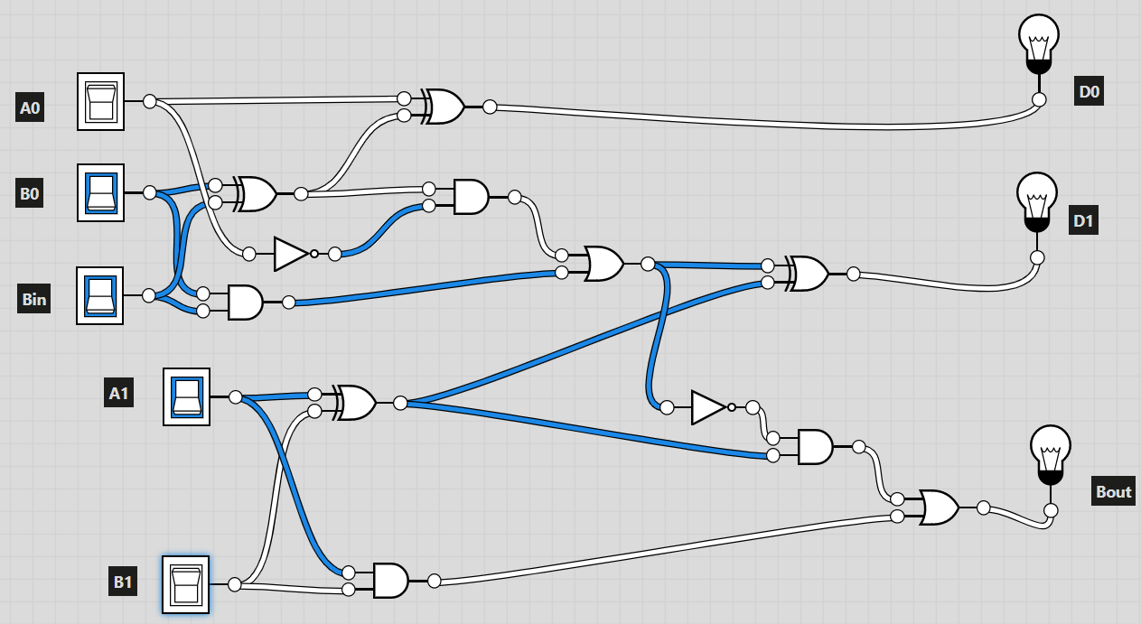

**A0=1,B0=0,BIN=1,A1=1,B1=1**

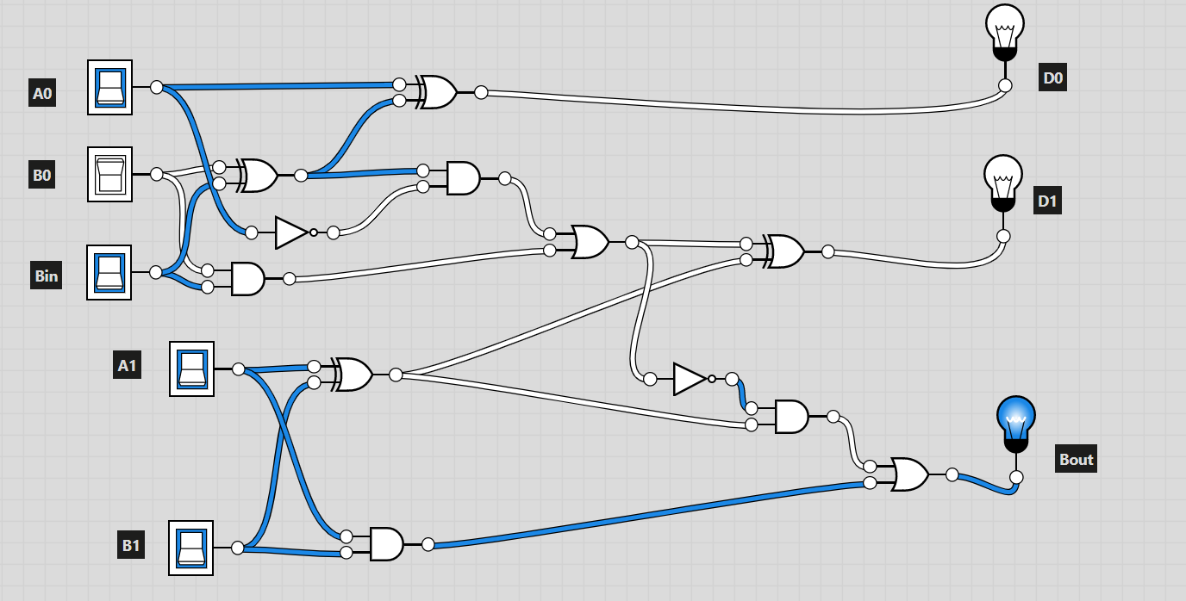

**A0=1,B0=1,BIN=0,A1=0,B1=0**

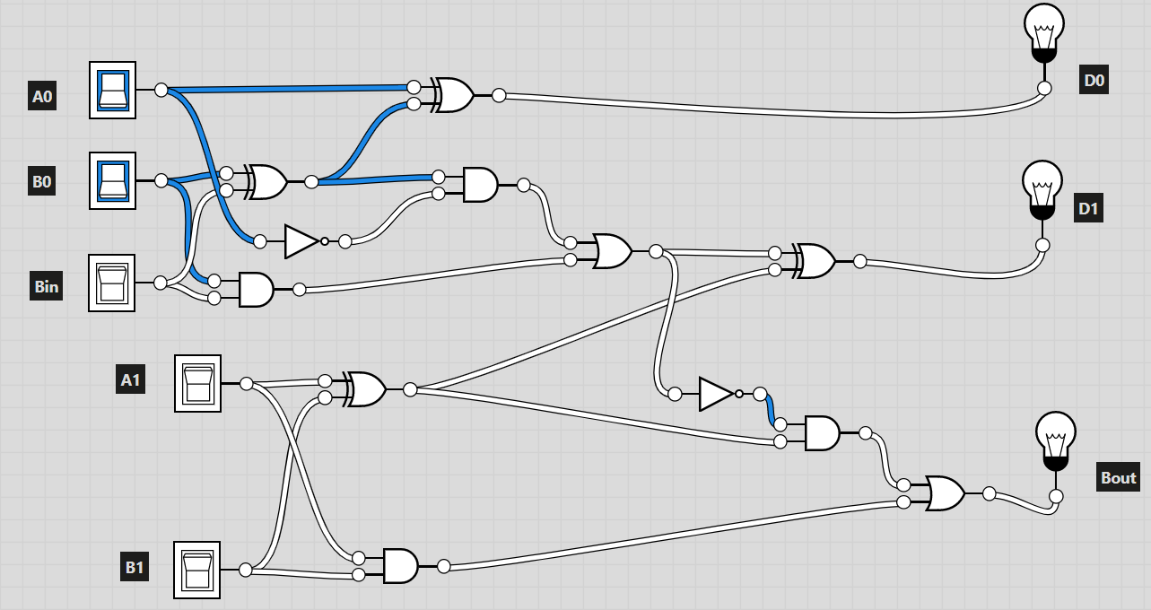

**TRUTH TABLE**

